Types of Data-Questions
Key Stage 3: Paper 2 Level 3-5
1.
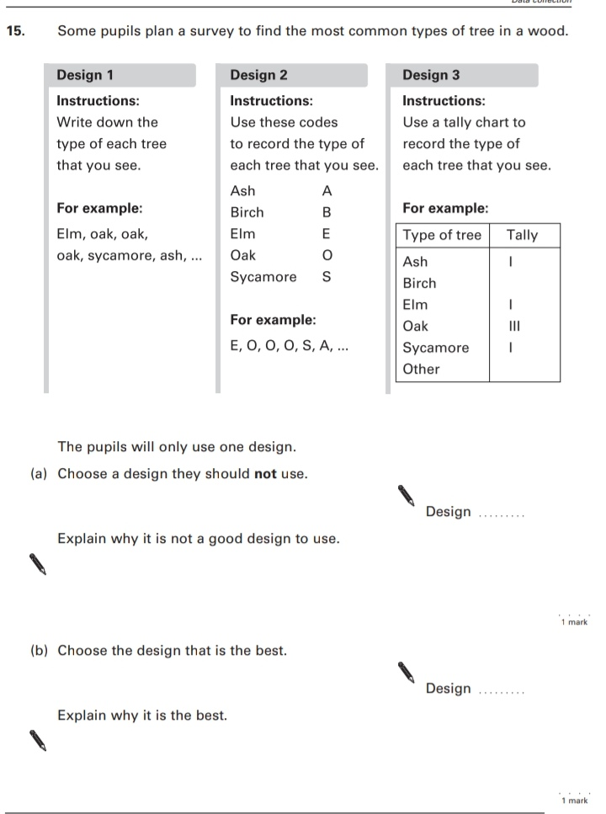
Key Stage 3: 2003 Paper 2 Level 4-6
2.
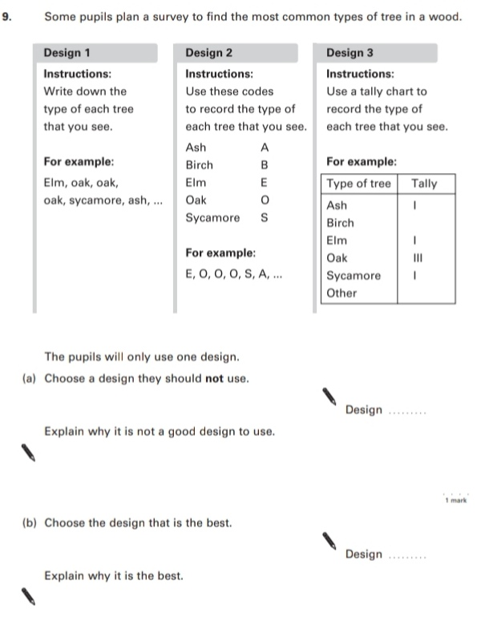
Key Stage 3: 2004 Paper 1 Level 3-5
3.
